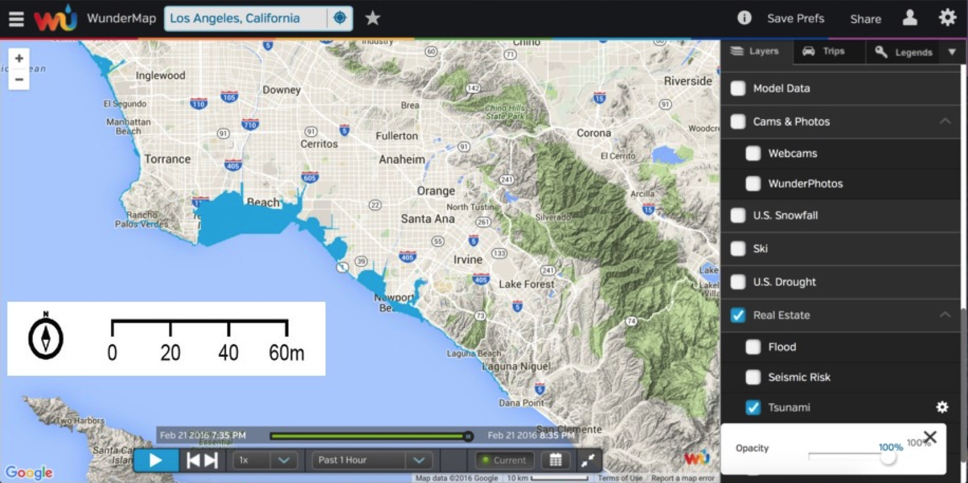

This picture shows a tsunami occurring in the city of Long Beach. The blue means high levels of sea level taking place. This is taking place of the night of February 21, 2016 at 8:35 in the City of Los Angeles, California. Tsunami’s mainly occur because of earthquakes that take place by sudden movement in the ocean such as earthquakes, volcanic eruptions, landslides on the seafloor, and slumping of land. [CWARN, 2016] Although the diagram shows a great amount of blue, nothing is really taking place in Long Beach. Waves are higher than normal, but everything still seems okay. Tsunami’s can be taking place all throughout the state of California due to El Nino. Due to our climate change we are now facing 80 degree weather in winter.

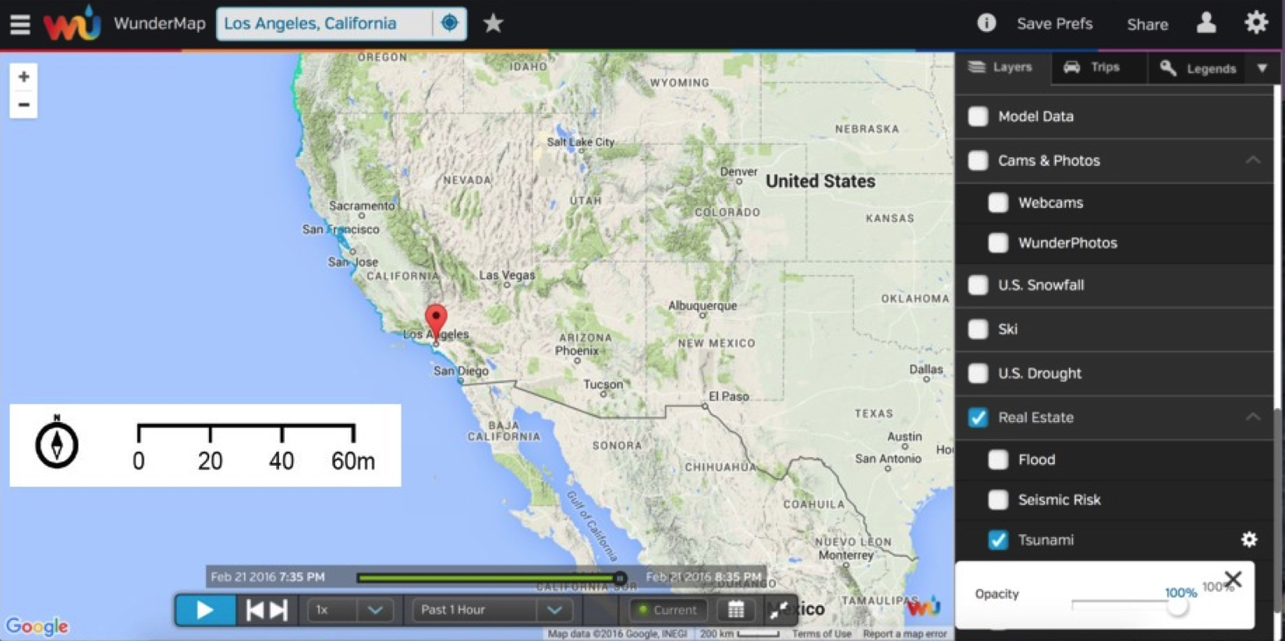
The dark blue indicates the tsunami wave levels. As we can see in this photo its happening all over California. I think it’s happening in California because we sit on active seismic waves. Which means these active seismic waves every time we feel an earthquake it’s because of the tectonic plate boundary(San Andreas Fault) that’s why the state of California is experiencing this high levels of waves at this moment. It will continue to happen because of the climate change that has been taking place because of El Nino. [Wikipedia, 2015]

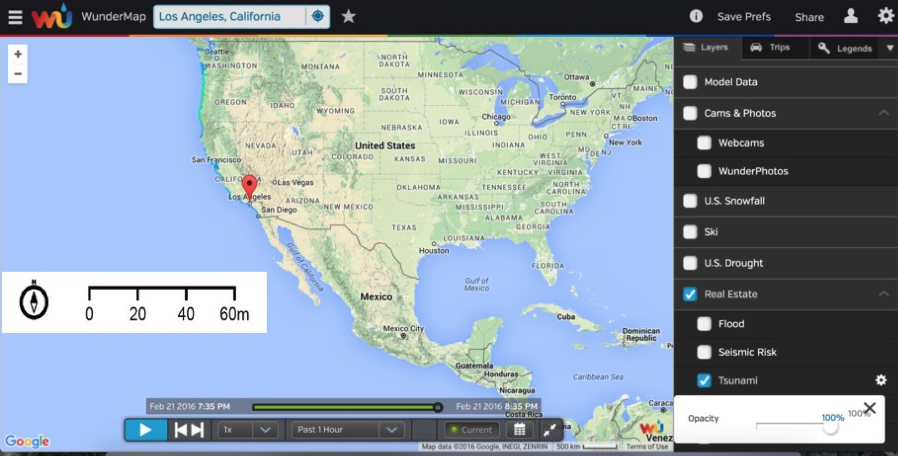
This is a map of the whole United States as of 2/21/2016 8:35 PM. We can see that tsunamis or in other words high sea levels are taking place in Washington to California. The high levels are starting from Washington to Los Angeles. This is because of the warm temperatures in the air, thats causing all the high sea levels. Also like I have stated above where the tsunamis are taking place it is because of the earthquakes that can be taking place under the ocean on the sea floor.

https://en.wikipedia.org/wiki/List_of_earthquakes_in_California
http://cwarn.org/footer/disclaimer
http://www.thefreedictionary.com/El+Nino

